**Grace Preschool School Supply Requests**

(Please bring to meet the teacher night or the first day of school)

Please do **NOT** label with student’s name. Thank-you

1. (2) POLY 2 pocket folders (Mrs. Fadness – GREEN, Mrs. Sinnaeve – PURPLE, Mrs. Axe – BLUE, Mrs. Leese- YELLOW, Mrs. Austin – RED, Mrs. Stronczek – RED)

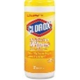2. (1) 2 pocket folder (Same colors as above)

3. (1) Container of bleach wipes

OR

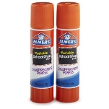4. (1) Box of Kleenex

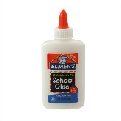5. (2-4) Glue Sticks

6. (1) Bottle of School Glue

7. (1) Roll of paper towels

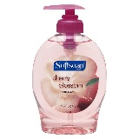8. (1) Container of Baby Wipes

9. (1) Bottle of hand soap

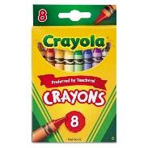

10. (1) Box of 8 CRAYOLA crayons

11. (Wish List) Sharpies